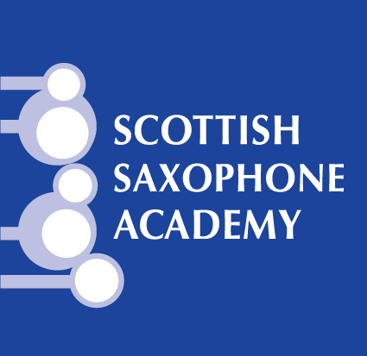

Summer Saxes

3rd – 7th August 2020

Minimum playing standard Grade 5

Please email your completed booking form to scottishsaxophoneacademy@gmail.com

Name:

Address:

Age:

Telephone number:

Email:

Parent / guardian / emergency contact name and contact details:

What saxophones can you bring (SATB) and what is your playing standard:

Any other information or medical requirements we should be aware of?

Booking Terms -

This Scottish Saxophone Academy course will normally run with a minimum of 12 participants. In the unlikely event of the Scottish Saxophone Academy having to cancel the course, as much notice as is reasonably possible will be given and all monies (minus maximum 50% of deposit) will be refunded to the participant.
If you are prevented from attending the course, you may transfer your booking to any other appropriate person free of charge, provided reasonable notice is given before the start date of the course and that there are no other changes to the booking details.
Course itineraries shown are guidelines only and may not be always strictly adhered to.
A booking is accepted upon payment of the total costs, or £100 per person deposit. If you only pay the deposit fee when making your booking, the remaining balance is to be paid within four weeks of the date of deposit payment. If you are booking within four weeks of the start of the course, you must pay the full fee, including the deposit. If this payment schedule is not adhered to, Scottish Saxophone Academy reserves the right to cancel your booking.
All participants must be adequately insured in case of any sickness, injury or accidents, however caused, and for cancellation. We also advise participants to have their own holiday/holiday cancellation insurance. If you have to cancel and cannot transfer your booking to another appropriate person, the following charges will apply:
4-8 weeks before course – 60% of total booking fee (deposit + additional fees)
2-4 weeks before course – 80% of total booking fee (deposit + additional fees)
2 weeks or less before course – 100% of total booking fee (deposit + additional fees)
If the course is disrupted due to events beyond the control of the Scottish Saxophone Academy (eg force majeure), any additional expenses incurred through delay, disruption or accident shall be borne by the client.
Any relevant medical conditions must be declared at the time of booking.
Any participant causing disruption, disturbance, damage or annoyance to other participants, leaders, property or third parties will be expelled from the course with no refund. This includes any person who fails to advise us of a medical condition or disability which prevents their full participation in the course.
Once your deposit has been received and you have retuned this booking form, you have implied acceptance of the above conditions.

